Southern Morocco Culinary Adventure, with Fouad ZARROU
March 06-15, 2023.
Itinerary, Terms & Conditions
Version 5
Ahlan Wa Sahlan, I welcome you!

As a coastal North African country, Morocco is a beautiful mix of Roman, Arabic, French, Spanish, and Berber influences. The result is a unique and timeless style, one that will stay with you long after your return home.
I look forward to sharing highlights with you and perhaps inspiring you to join me on this trip.
I have set up meet-and-greet experiences with locals putting an emphasis on the women of Morocco, enabling us to have a deeper, more authentic perspective on the Moroccan lifestyle.
Of course, we’ll spend time discovering hidden gems in the souks and explore bustling cities where ancient traditions meet modern ones. We’ll experience a traditional hammam ritual, and the ubiquitous mint tea will relax us.

Organized with Moroccan-born Fouad of France Azur Excursions, Nice France, the trip will take us from Marrakech across the Atlas mountains to the oasis town of Ouarzazate, then into the Sahara desert for three nights in a desert camp at “Erg Chegaga,” ; the most authentic desert in Morocco–far from mass tourism.

The desert camp is the perfect “glamping getaway” to experience this extreme landscape with all the comforts of home. In the evening, we’ll sit around the fire as we are treated to dinner and traditional Gnawa music that tells a story of ancient peoples through its enchanting rhythms.

After departing the desert, we will continue through fertile agricultural land, meeting on our way, craftswomen and craftsmen, and find the sea at mythical Essaouira, a surfer’s paradise, on the Atlantic coast, before returning to Marrakech.

Morocco is full of mystique and surprises, with some of the most awe-inspiring landscapes that you can’t find anywhere else. And, of course, the kitchen–Moroccan food is said to be some of the best in the world.

This is the Morocco of your dreams.
Group size : Min 8 guests. Max. 11 guests.

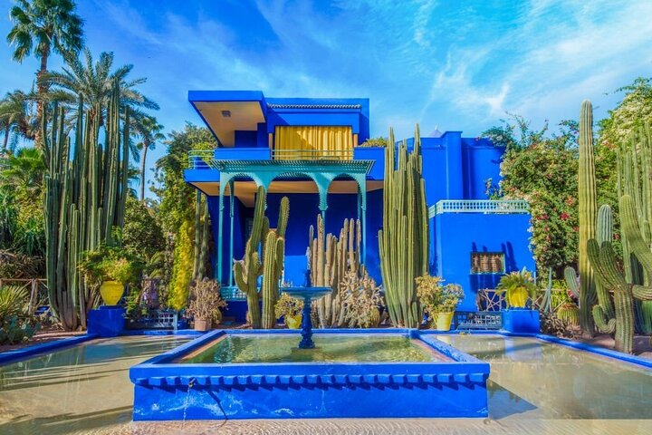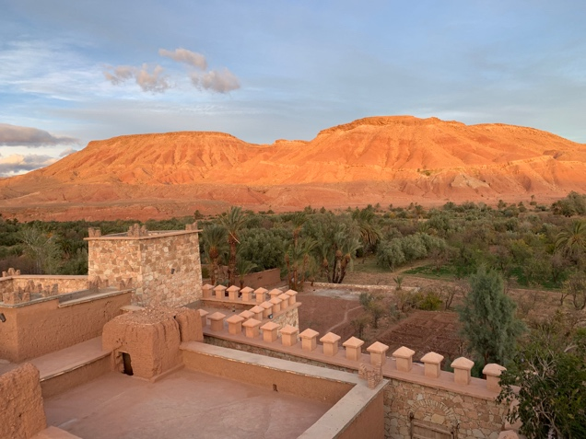
Sunday, March 06: Arrivals and welcome dinner in Marrakech
Marrakech arrivals. The city was founded in I062 by the Almoravid dynasty, which is known all over the world. Please note that airport transfers in both directions are included in the cost of the tour and will be organized by Fouad, even if you are arriving prior to the 6th and leaving after the 15th.
For those who are already in town, a casual tour will be offered: visit El Medina, Souk, Médersa ben Youssef, followed by a welcome dinner in a local restaurant. Stay at the Riad Orangeraie.

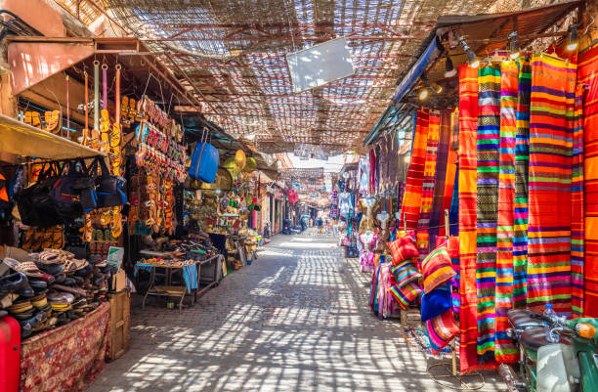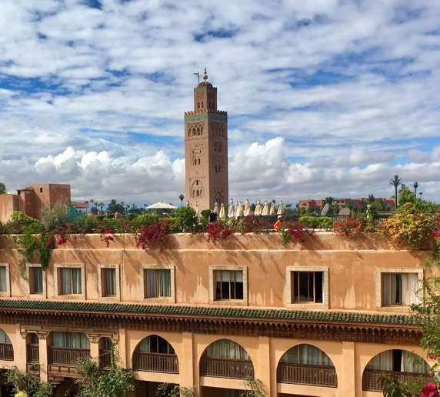

Monday, March 07: Marrakech & Moroccan cuisine
The day will be begin with a cooking class at the Amal women’s center in the Targa area of Marrakech, which trains underprivileged women to help them become independent. Learn to make a tagine or couscous!
In the afternoon, visit the stunning Majorelle garden, which was designed by the French artist Jacques Majorelle over a span of 40 years starting in 1922, and bought by Yves Saint Laurent in 1966. Those who are already familiar with the Majorelle garden have the option of returning to the hotel for a rest, spa treatment, or exploring the souk. We’ll go on an evening food tour of the UNESCO heritage square Jemaa el-Fna at the market’s food stalls. Stay 2nd night at Riad Orangeraie.

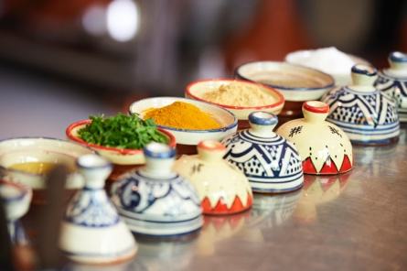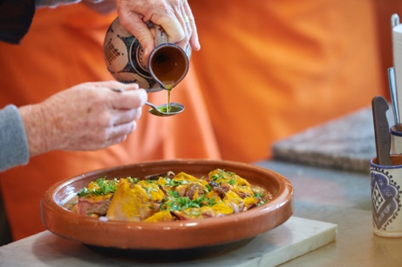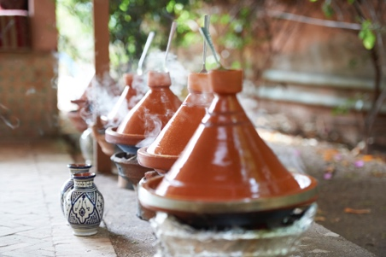

Tuesday, March 08: Ouarzazate
We will drive through the Atlas Mountains towards the desert, and the Tichka pass located at 7414 feet height. We’ll stop at a mountain village along the way and enjoy lunch with a view at the Auberge Restaurant Telouet, overlooking the “Glaoui Kasbah.”
We’ll continue our drive to the ancient kasbah Aït Benhaddou, site of films such as Lawrence of Arabia and Gladiator. From here it’s a short drive to the small city of Ouarzazate, the gateway to the desert and the spectacular lights. We’ll check into our hotel, Kasbah Riad Dar Chamaa, and have dinner at the beautifully restored Kasbah des Sables, which blends French and Moroccan cuisines. Kasbah Riad Dar Chamaa.
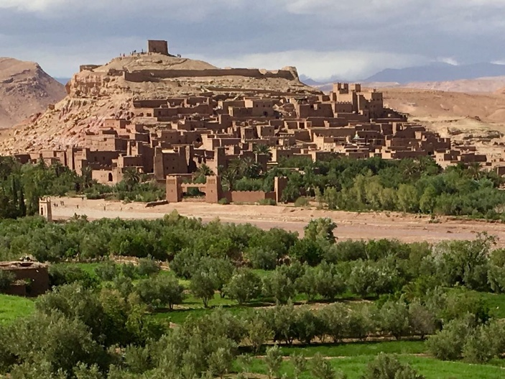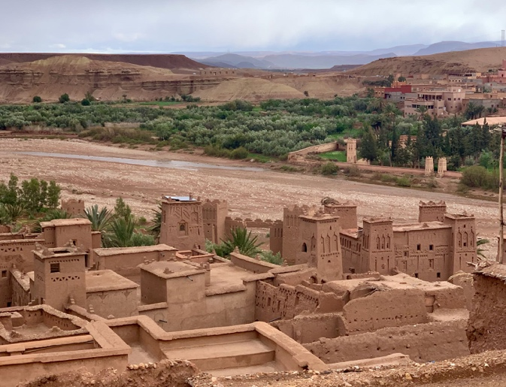

Wednesday, March 09: Oasis & Desert camp “Erg Lihoudi”
Before leaving, stroll through the small traditional streets in Kasbah Taourirt lined by workshops...
We will enjoy a traditional lunch in Zagora, then stop to explore the village and crafts of Tamegrout, which renowned for its unique pottery in elegant shades of green produced by local families.
Visit the Tinfou Oasis, an example of a semi-abandoned village, with a few families trying to survive in drought conditions. Growing date trees and wheat along the Dra’a river, they prove their own resilience.
We’ll then drive to the desert camp “Erg Lihoudi”, transferring to 4X4s for the final part of the drive. Upon arrival, we’ll get settled in our luxury tents (complete with a bathroom and shower) and enjoy the surrounding scenery. this is your chance to ride a camel, or simply relax in camp, and/or explore the scenery. We will attend a traditional desert music group before enjoying dinner at the camp and marvelling at the starry sky. First night in desert camp Erg Lihoudi (Taragalte Luxury Desert Camp).

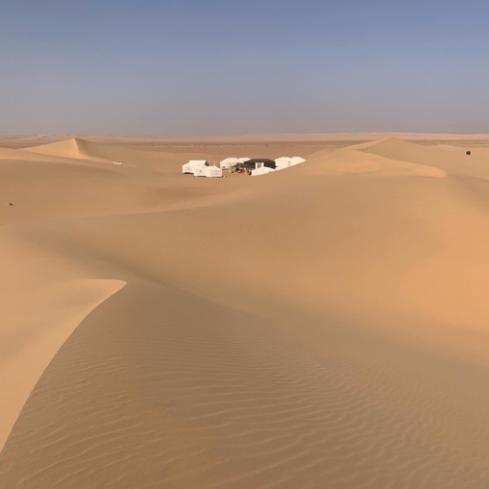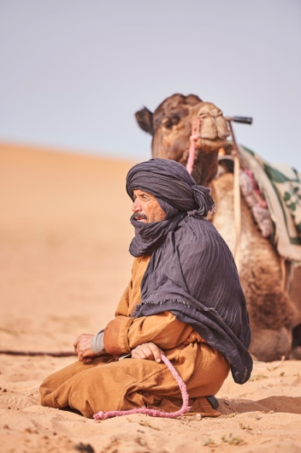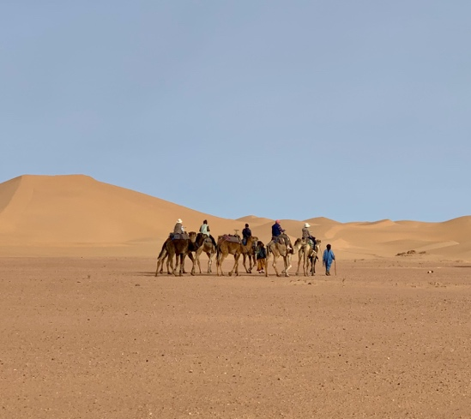

Thursday, March 10: Drive to desert camp “Erg Chegaga”.
Early risers can wake up early to experience the sunrise over the Sahara.
After breakfast, we’ll pack up the luggage that will be left in the tents, then go on a 90-minute hike to experience the emptiness around us. Lunch will be a picnic in the dunes.
After lunch, the 4x4s will pick us up to transport everyone to the second desert camp, “Erg Chegaga,” a 90-minute drive. This desert camp is the biggest in Morocco (and Fouad’s favourite). The desert camp offers a comfortable base to explore the beautiful wilderness and bring guests close to nature. The nearest road is a 2 hour journey away, the closest light pollution 60km away. This is the perfect location to be disconnected from civilization.
We’ll enjoy the sunset and dinner at the second desert camp “Erg Chegaga.” Second night in the camp.

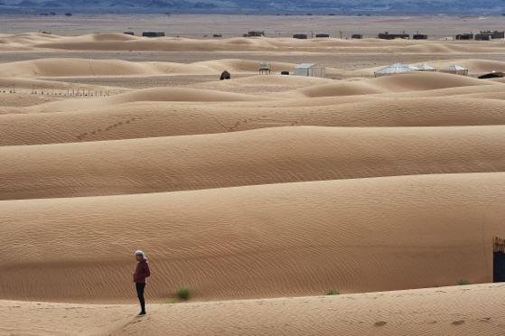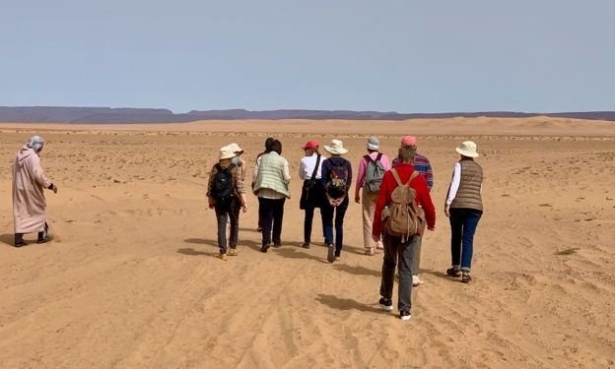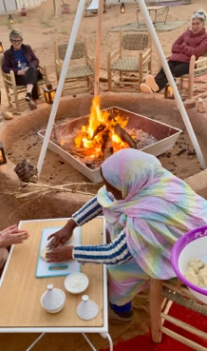

Friday, March 11: Erg Chegaga camp.
Again, if you wish, early wake-up to experience the sunrise over the Sahara.
Breakfast, then you have two options: a 4x4 and hike to discover more of the desert dunes and the nomad camps. Or stay at the camp to enjoy your free time. Lunch will be a picnic in the desert at the nomad village. For those wishing to explore on their own from the camp, or just rest in camp, a picnic lunch will be provided at the camp. We will dine and we will spend the second night in the camp Erg Chegaga. Stay 2nd night at Desert Camp “Erg Chegaga” (and 3rd night in the desert).

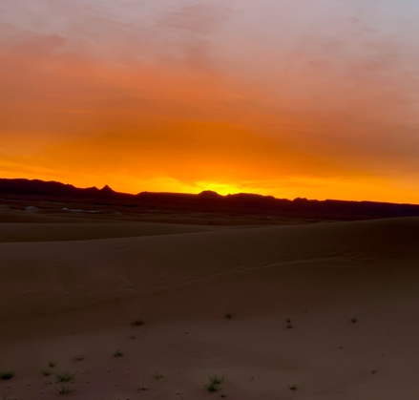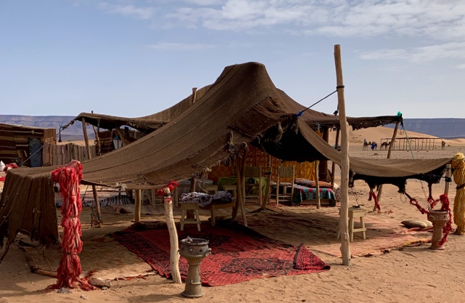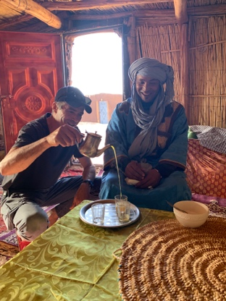

Saturday, March 12: Drive through the desert to Foum Zguid
Another opportunity to wake up early and see the sunrise over the Sahara and eat breakfast. We’ll leave the desert camp and head back into civilization. The drive will take around 3 hours along spectacular Sahara views.
We’ll stop in Foum Zguid to spend a night there in hotel/Riad Bab Rimal.

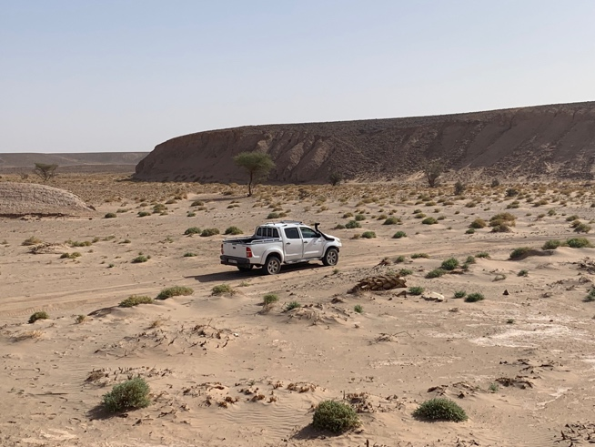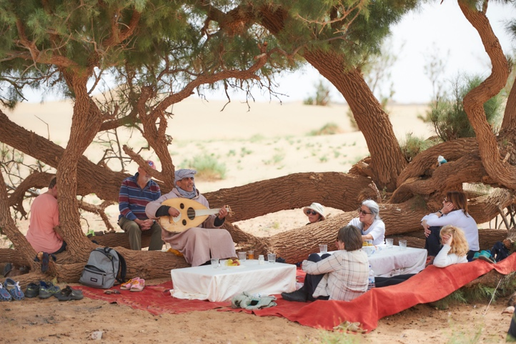

Sunday, March 13: from Foum Zguid to Taroudant
Today, we drive towards the villages crafts.
We’ll leave Foum Zguid and head in the direction of Taroudant. We’ll make a stop in Tazenakht, a village known for its female-run carpet cooperatives, and visit a cooperative. We will then continue to Taliouine, a Berber village in the Souss valley that is the center of saffron production in Africa, and learn how saffron is produced. We’ll stop for lunch at a restaurant in Taliouine and continue driving through spectacular scenery to the walled city of Taroudant, which many describe as a small version of Marrakech. Upon arrival in Taroudent, we will stay in the hotel Dar Zitoune, which has a beautiful botanic garden, and enjoy dinner out in Taroudant city. Dar Zitoune

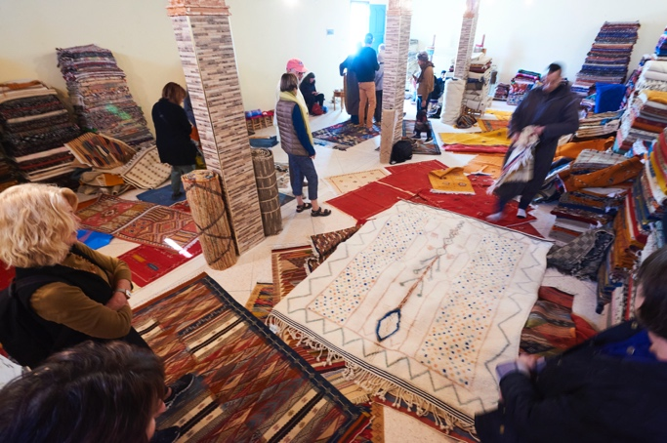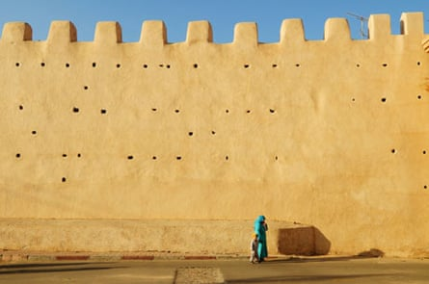

Sunday, March 14: Taroudant to Essaouira
We’ll leave Taroudant to drive to Essaouira, a fishing port on the Atlantic coast. We’ll then stop for lunch in the small town of Taghazout, which is popular with surfers, before continuing our drive to Essaouira. This area is where the argan trees grow in Morocco. We’ll have the opportunity to stop at the women-run argan cooperative before checking into the charming Riad Chbanate in the old town of Essaouira. We’ll take a walk, eat dinner at a local restaurant in Essaouira and stay the night at Riad Chbanate. Riad Chbanate.

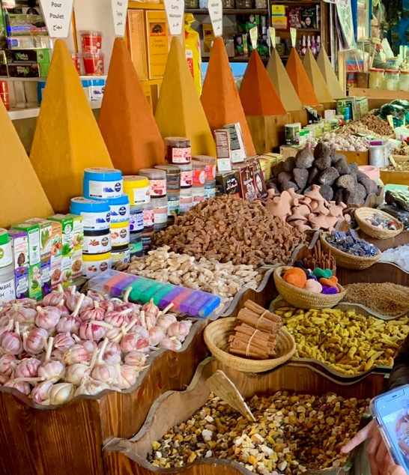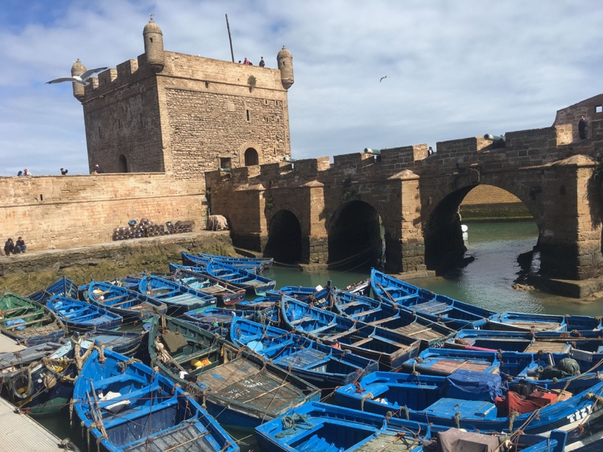

Monday, March 15: Essaouira to Marrakech
Visit the Essaouira souk, with an opportunity to buy spices and more. We will have a casual lunch at the fish market in the port, then depart. On our way to Marrakech we will make a stop to the Domaine du Val d’Argan, winery, to learn about the area’s wine.
Continue driving to Marrakech, where we will check into the boutique hotel 2 Ciels in Gueliz. We will have a dinner at Al Fassia, a female-run restaurant in Gueliz.

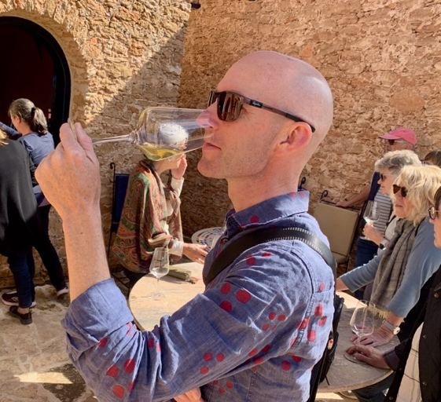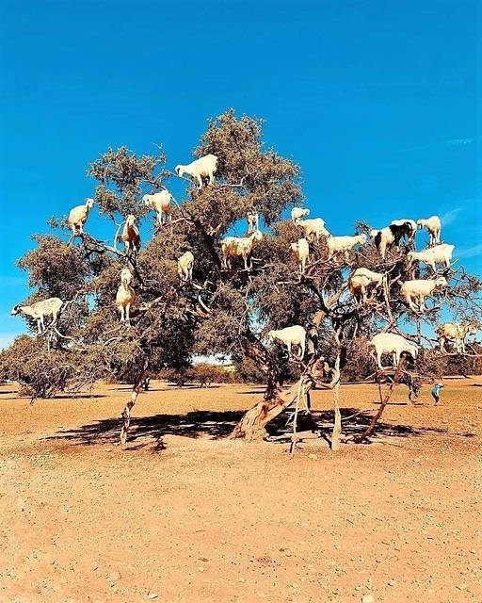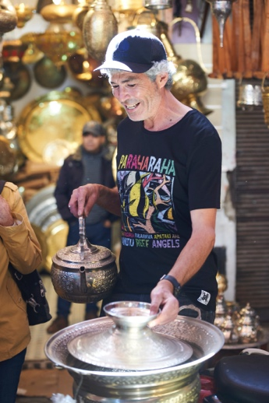

Tuesday, March 16: Marrakech departures. Airport transfers
Again, please note that airport transfers in both directions are included in the cost of the tour and will be organized by Fouad , even if you are arriving prior to the 06th and leaving after the 15th. Please note that the depart should be from Marrakech airport (RAK) in Morocco. If you travel from France (Paris or Nice), there are a direct flight to Marrakech airport.

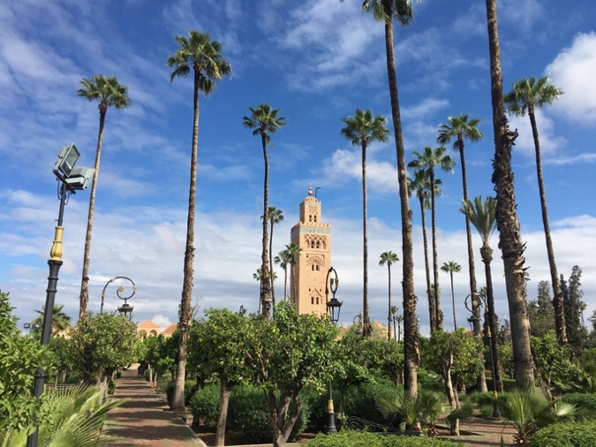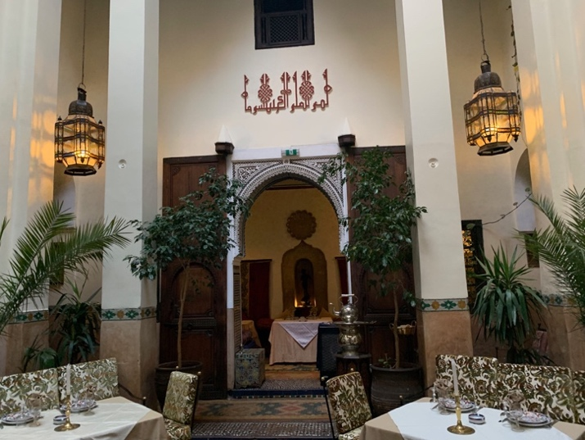

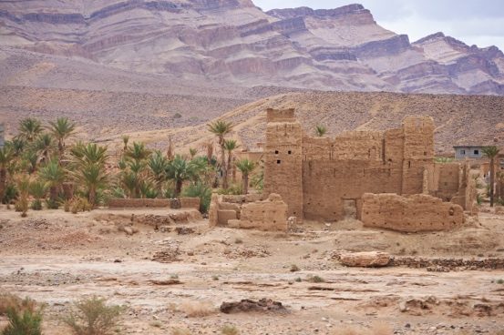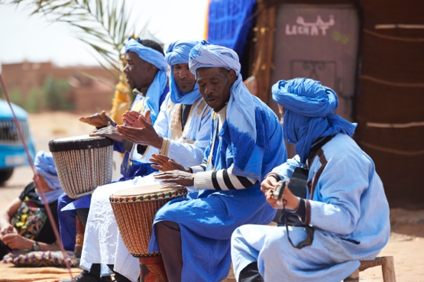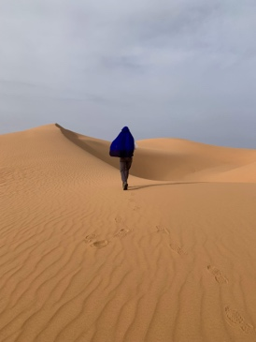

Highlights:
- Medina’s Souks, Majorelle Garden, Marrakech
- Souk El Malleh (Jewish spice market), Maderassa ibn youssef, Marrakech
- Learn how to cook an authentic Moroccan tagine in a hands-on cooking class in Marrakech
- Atlas mountains: Tichka pass 2600m
- Kasbah Glaoui and Ouarzazate
- See the famous green pottery in Tamegroute
- Tinfou Oasis
- Desert camp Erg Lihoudi and Erg Chagaga: the most authentic and wild desert of Morocco. Experience sunrises & sunsets and beautiful drives through the desert
- Hike and picnic on the dunes and nomad camp
- Visit the Argane, Safaran and Carpet cooperatives
- Essaouira, the Portuguese city fishing port
- Wine tasting: Val d’Argan

Who is Fouad ZARROU
I was born and grew up in Morocco, and some of my family still lives there. I left Morocco to study international law at the Sorbonne Paris, eventually working with Unesco's legal affairs department. But, I gave up my desk job because I wanted to find a way to share my sense of adventure, plus my love of humanity and nature. Since 2012, I’ve been running a tour guide company in Nice, French riviera, France Azur Excursions. Morocco's deep history, its authentic and colourful culture, its varied breath-taking landscapes, its culinary knowledge, and its mystique drew me to share the secrets of this country with passionate guests. I am familiar with all the secret trails and little-known spots of the southern Morocco, and because of my heritage and speaking English, French, Berber and Arabic, I am happy to lead you off the tourist path and arrange outdoor activities for enthusiastic adventurers.

I will be your Tour Manager and a part of the group. I will be your local guide as well, and working with all local vendors and partners to insure your comfort. I’m with you to look out for your needs, safety, to help resolve issues, and to make sure you get what you want from your trip. Please don’t hesitate to contact me with any and all questions at fzarrou@gmail.com or we can speak via Zoom or phone (+33 6 20 68 10 70).

France Azur Excursions
21 Corniche Andre de Joly, 06300, Nice, France
Phone: 33 620 681 070

What is the weather like in Morocco in March
March is a great time to visit Morocco. It is the beginning of Spring. The average temperature in Morocco in March is a comfortable 68F-75F, depending on the area of the country that you visit. Nights can still be chilly, with temperatures between 50F-55F. When we cross the Atlas Mountains, we may see traces of snow. Note also the desert nights can be brisk with wind.

What is included ?
- All in-Morocco transport with the group, including airport transfers, our 20-seat minibus with a local driver, and 4x4s in the desert.
- All meals (excluding alcohol), accommodation, group activities, cooking classes, experiences and tastings.
- Alcohol will be provided/included only in the Desert Camps.
What is not included
- Airfare to and from USA/Morocco International Airport. Flight’s should arrive at Marrakech Menara Airport, Morocco
- Recommended travel insurance and medical care
- Personal shopping and expenses
- Alcohol (except in the Desert) not included in the itinerary
- Any expenses incurred during free time
- Optional excursions or extensions, not listed
- Non-refundable passport fees
- Excess baggage charges

Pricing and Payments
Pricing per person:
  - Double room: 5,500 Euro
    - King size bed, for couples. You will have a private room for the duration of the trip.
    - or 2 singles beds for the shared rooms. You will share a room with one other guest for the duration of the trip.
  - Private room, one person: 6,300 Euro. You will have a private room for the duration of the trip
  - Payment dates
    - A deposit 2,000 Euros is due by 25th December 2022 to secure your place on the trip
    - Final Payment for the remaining balance is due 25th January 2023.

Visa and Passport
To travel to Morocco you do not need a special visa to enter the country. We can stay in the country for less than 90 days without a visa. Please be sure you have enough empty pages in your Passport and that it is valid for a full 6 months after the date you return from this trip.

What day should I arrive?
The trip officially starts on the afternoon of March 6th, but if you are traveling across an ocean to get to Morocco, you may want to consider arriving a day early so you have time to relax and get acclimated to the local time zone. If you do decide to arrive early, I can help you book your rooms (please note those rooms will be your cost and not included in the trip price). Please fly into Marrakech airport (RAK) in Morocco. If you travel from France (Paris or Nice): there are a direct flight to Marrakech airport.

Alcohol consumption
Morocco is a Muslim country, so alcohol is not always available. Most restaurants we go to will have wine and beer, especially in the big cities: Marrakech, Ouarzazate, Essaouira, Taroudant hotels. I will provide alcohol at the desert camp. (Please note that alcohol is not included in the package price.). Also, you may certainly purchase your own alcohol to consume with dinners or aperitives.

Accommodation
All accommodations will be in riads and hotels chosen for their beauty, comfort and authentic character, including the luxury desert camp.

Group Activities
This trip will require some physical abilities. We will walk a lot in souks and for the street food tour, visiting monuments, plus a long hike in the desert, riding camels, etc. If you can't walk for any reason, this trip is not for you. By making a booking, you represent that you do not have any physical or other conditions that would create a hazard for you or other Participants or affect other people’s enjoyment of the trip.
This trip will be best enjoyed by a group with open minds. The locals are very friendly, warm people and ready to help
Travel Arrangements
France Azur Excursions, will email you when it is time to make your travel arrangements. It will include a detailed itinerary, arrival and departure information, a suggested packing list, useful country information, emergency form and more.

Changes in Itineraries and Program Assignment
- France Azur Excursions reserves the right to make any necessary changes in fees, departure cities, itinerary sequence, trip direction, hotels, optional excursions, and activities in the event that these changes become necessary for any reason.
- France Azur Excursions may cancel the program due to insufficient enrolment, unforeseen operational difficulties, natural or man-made disasters, terrorist attacks, or for any other necessary or unforeseen reasons.

TRAVEL INSURANCE
You acknowledge that travel insurance coverage is not included in the cost of this trip offered by our company. It is mandatory that all the guests should have is own travel insurance. Travel insurance must cover personal injury, medical treatment, repatriation, and evacuation expenses…. It is recommended that travel insurance also address personal property and trip cancellation coverage. Trip cancellation insurance may be the only means of receiving reimbursement for flights and other non-refundable expenses should a trip be cancelled for any reason, whether voluntarily by you or as a result of our actions. You are responsible for understanding the specifics of your travel insurance policy, ensuring that your policy covers all included activities listed in the trip itinerary, and ensuring that there are no exclusion clauses that would limit the coverage that you might reasonably need. If you have current health insurance coverage, check your insurance policy to see if it provides the coverage described above while traveling outside your country. You also agree to assume all costs of medical care, evacuation, transportation, and related costs.

Cancellations
- Cancellations made on or before January 25, 2023: deposit and any trip payments will be reimbursed by wire bank, and in full, minus a cancellation fee of 500 Euros.
- Cancellations that occur after January 25, 2023 up until the departure day of the trip must be handled by your personal travel insurance. France Azur Excursions will not issue any refunds of any amount after January 25, 2023.
- If two people book a room together and one of the persons cancels the trip for any reason, France Azur excursions reserves the right to fill the space with another guest unless the remaining guest chooses to pay the additional fee for a single supplement room.
- France Azur Excursions may cancel the program due to insufficient enrolment, unforeseen operational difficulties, natural or man-made disasters, terrorist attacks, or for any other necessary or unforeseen reasons. France Azur Excursions will provide a full refund of any funds deposited by guests if the minimum number of guests required (8 people) isn’t reached minus the bank fees.

Force Majeur
France Azur Excursions will not be deemed in breach of this agreement or otherwise liable to you, by reason of delay in performance or nonperformance of any of its obligations under this agreement to the extent that any such delay or nonperformance is due to any Force Majeure. (“Force Majeure” means any circumstances beyond the reasonable control of France Azur Excursions, including without limitation acts of God, terrorist activities, insurrection, explosion, flood, tempest, forceful wind, fire or accident, war or threat of war declared or undeclared, sabotage, civil disturbance, labour strikes, requisition, sickness, quarantine, government intervention, weather conditions, and unforeseen circumstances.)

To reserve your spot, please contact us at fzarrou@gmail.com to send you the forms and the details. To confirm your participation, we will require a deposit of 2000 euros by December 25, by wire bank (Wise bank system is recommended to avoid to pay hight bank fees), and/or full payment payable to France Azur Excursions. The balance of your payment is due January 25, 2023.

